Top right corner we can select region; it is advisable choose nearest region geographically from your location. For Pune Mumbai is nearest

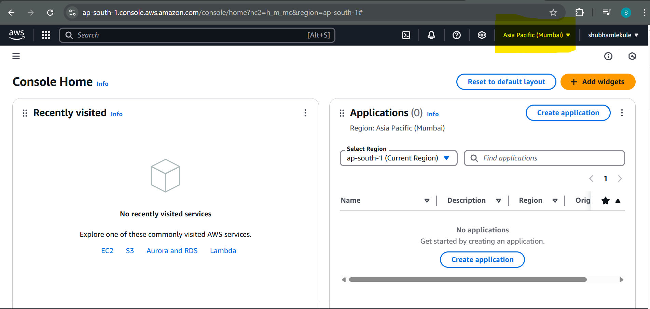

In this recently visited section it will show all recently used AWS services as shortcut. For now its empty as I don’t use any as of now.

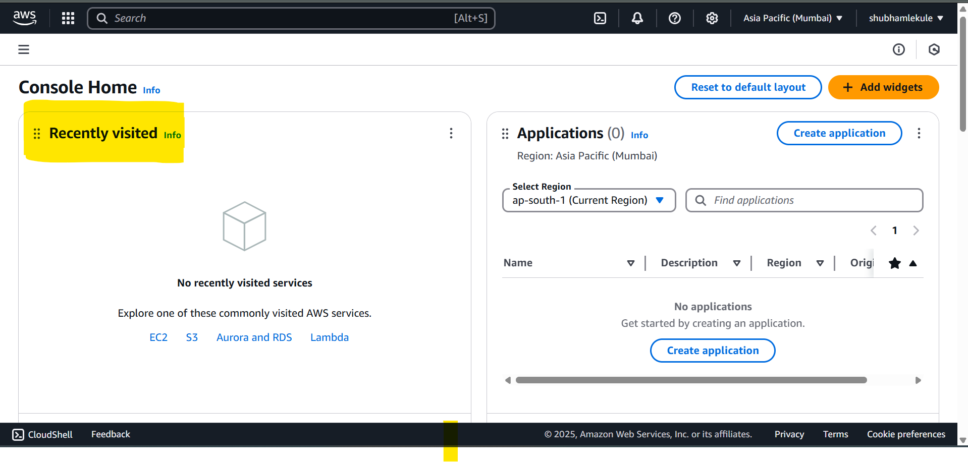

Once we visited any service it shows in recently visited :

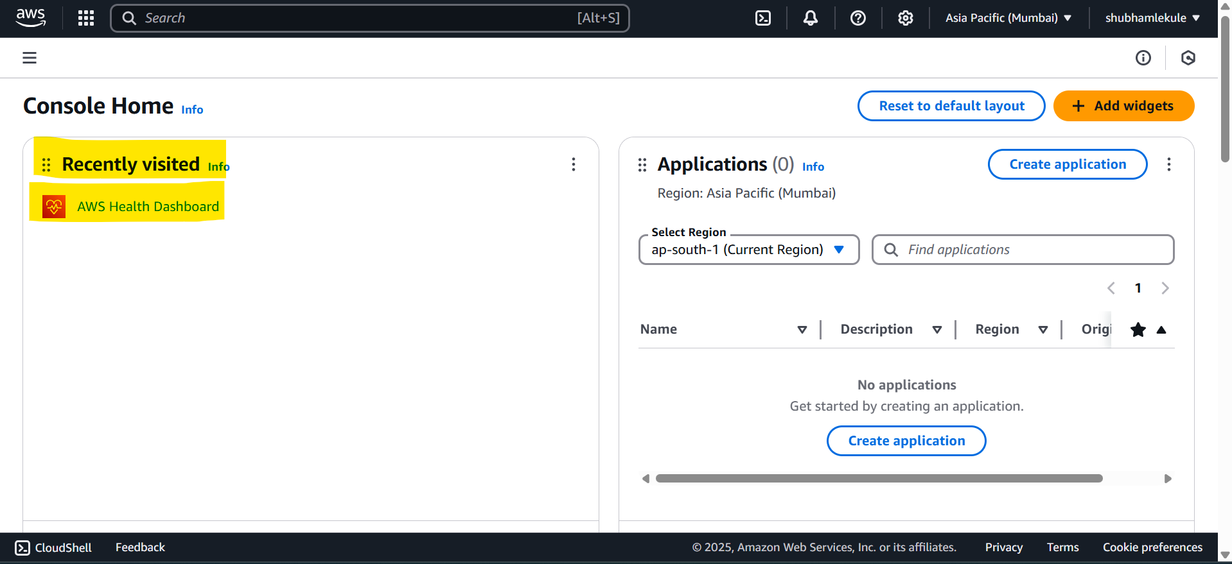

Once done with udemy course visit below:

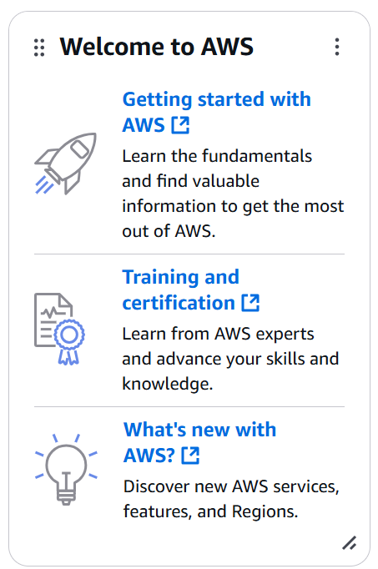

<https://aws.amazon.com/training/>

Any notification and health of service related information:  
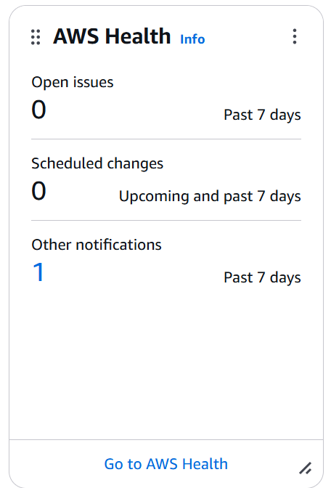

Either we search or find category wise services:

